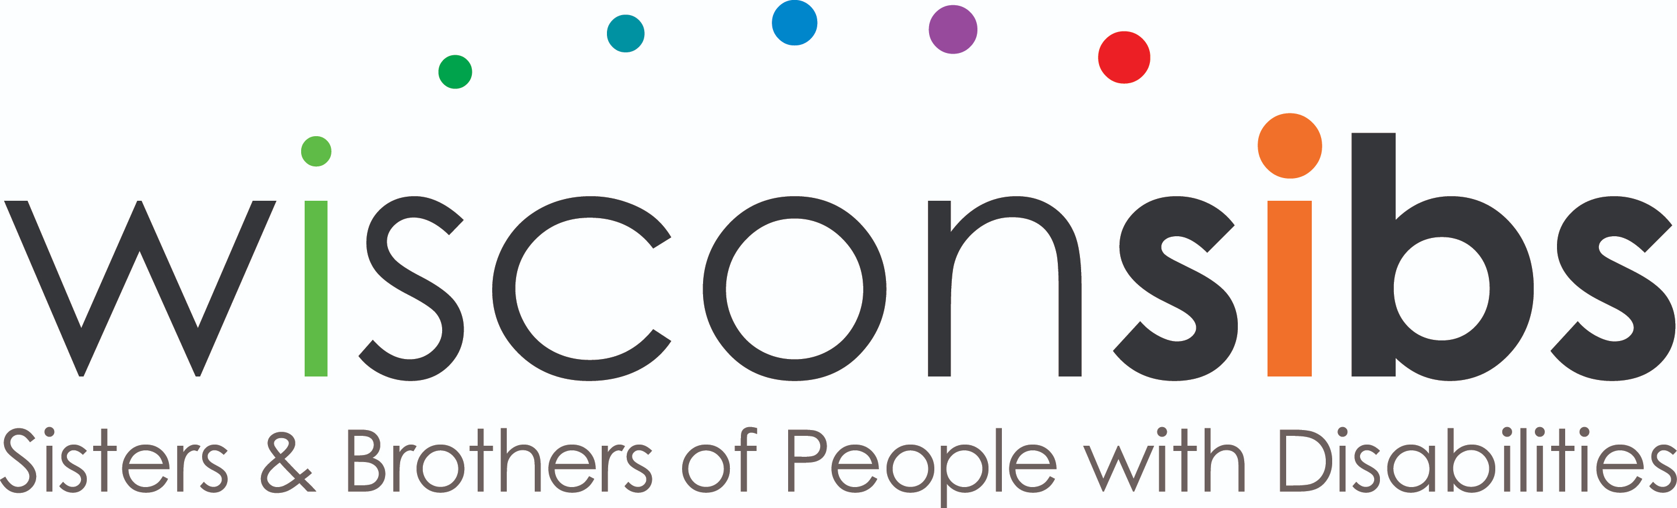

NEWS RELEASE

Contact: Emily Askri, Adult Sibling Program Coordinator
WisconSibs, Inc.
211 E. Franklin St. Appleton, WI 54911
P: 920-968-1742 E: emily@wisconsibs.org

Caregiving fact sheet attached

November 29, 2023

Wisconsin Siblings Thankful for Caregivers

As we celebrate National Family Caregivers Month this November, WisconSibs is honored to recognize four local individuals for the care they provide to people with disabilities. For fourteen years WisconSibs has been recognizing caregivers with the Sibling’s Choice Awards. Award recipients are nominated by the siblings of people with disabilities to acknowledge the care and security they provide to ensure their loved ones with disabilities have independent and fulfilling lives.

With over 53 million Americans providing unpaid care to family members, friends or neighbors, WisconSibs would also like to a moment celebrate and honor all caregivers. While most of us care for loved ones without hesitation, the added responsibility can be a big commitment. According to a 2020 survey by the National Alliance for Caregiving and AARP, over 60% of caregivers hold paid employment on top of their unpaid caregiving responsibilities.

You might be surprised to know that here in Wisconsin, 80% of Wisconsin residents who need long term care receive it from friends or family instead of from facilities. As it happens, all four of this year’s Sibling’s Choice Award recipients provide care to someone living at home or independently.

Tracy Scanlan, one of the Sibling’s Choice Family Caregiver Award recipients, has been a lifelong caregiver for her daughter. Nominated by Kiera Hau, Tracy “is not just a mom, she is a full-time caregiver who has sacrificed her life in more ways than people imagine. And even when it is hard, she does it all with a smile.”

Providing care for loved ones with disabilities goes beyond simply providing basic needs. Nominated by Staci Burton, Sawyer Burton is another Sibling’s Choice Family Caregiver Award recipient who demonstrates this every day. Sawyer was recognized for the fun, laughter, and excitement he brings to his aunt’s life while helping care for her.

Knowing that a loved one is well cared for is a huge relief for families of people with disabilities, and another of the 2023 Sibling’s Choice Family Caregiver Award recipients is proof of this. Joe Sauer, who was nominated by Lori Gagnow, has been caring for his daughter since she became ill. His family said, “I am so thankful and so glad Dad (Joe) is there with a loving heart and able to hands to care for her (his daughter). I just know he has brought us peace of mind when it comes to her care.”

This year, a new category was added to the awards to honor the contribution that siblings play in the lives of their brothers and sisters with disabilities. This category recognizes that siblings of people with disabilities may take on responsibility for caregiving tasks, even as young children, and often continue in a caregiving role for much of, or all, of their adult lives. Nominated by Thalia Mann, the first ever recipient of the Sibling’s Choice Siblings as Caregivers Award was given to Randy Young for the care he provides to his brother. Randy moved back to the Fox Valley after college to help care for and guide his brother.

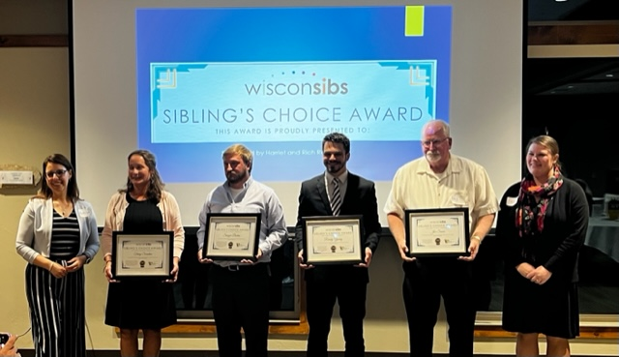
Pictured left to right: Katherine Bracho (WBAY), Tracy Scanlan, Sawyer Burton, Randy Young, Joe Sauer, Emily Askri (WisconSibs)

For more information, go to http://wisconsibs.org. WisconSibs, Inc is a member of the Wisconsin Family and Caregiver Support Alliance (WFACSA) and the Outagamie Caregiver Coalition.

RELATED FACTS:
The State of Family Caregiving in Wisconsin
Definitions
A caregiver - sometimes called an informal caregiver - is an unpaid individual (for example, a spouse, partner, family member, friend, or neighbor) involved in assisting others with activities of daily living and/or medical tasks.
Formal caregivers/Direct Care Workers are paid care providers providing care in one’s home or in a care setting (day care, residential facility, long-term care facility). For the purposes of the present fact sheet, displayed statistics generally refer to caregivers of adults.

Heavy Reliance on Family Caregivers in Wisconsin
In Wisconsin a shortage of formal caregivers or direct care workers has created a crisis for people with disabilities, older adults, and their families. The need for direct care workers is projected to increase by an additional 20,000 workers by 2026. In 2016, a statewide survey of more than 500 people who rely on direct care services and their families found 85% did not have enough workers to cover all their shifts 60% said they get sick more often when they do not have enough staff. Families are the backbone of the caregiving industry in Wisconsin, providing an estimated 80% of all care.

Local Caregiver Feedback: The Family & Individual Needs for Disability Support Survey

How does caregiving affect employment?
• 92% caregivers reported going in late or leaving early because of caregiving responsibilities.
• 83% of respondents worked for pay outside of caregiving responsibilities in the 12 months prior to the survey.
• 71% of caregivers reported cutting back hours.
• 52% reported giving up working.
• 42% turned down a promotion.
• 36% did not take job opportunities that require moving out of state.
• 31% reported losing benefits.
• 21% received warnings about attendance or work performance.

What worries caregivers about the future for their family members?
• 93% worry the quality of support will go down if they are not there to advocate.
• 90% worry she/he will have to live somewhere she/he does not want to live.
• 86% worry she/he will not have enough friends and social activities.
• 85% worry she/he will have difficulty advocating for what she/he needs.
• 85% worry she/he will not be able to contribute to major life decisions or receive support for self-determination.
• 84% worry there is no one else to provide the support they are giving.
• 82% worry her/his health will deteriorate.
• 82% worry some form of abuse or neglect might occur

1. State of Care: Wisconsin’s Home Care Landscape. PHO. 2017. https://phinational.org/resource/state-of-carewisconsins-home-care-landscape/
2. Survival Coalition Consumer Survey, November 2016. http://www.survivalcoalitionwi.org/wpcontent/uploads/2016/11/SurvivalSurveyFactSheet.pdf
3. Family & Individual Needs for Disability Support Report 2017 (Institute. on Community Integration and The Arc of the United States)

Impact of Working Caregivers on Wisconsin Employers
- More than 8 out of 10 caregivers in Wisconsin report having their work life interrupted
- 77% of Wisconsin caregivers have missed work due to caregiving responsibilities, most using vacation time, or other PTO
- 27% of Wisconsin caregivers have not taken any vacation for over a year
- Most Wisconsin caregivers have been supporting an individual for 1-5 years
- Over half feel their current level of support is unsustainable

2021-2022 Wisconsin Employer and Working Caregiver Survey

State of Care: Wisconsin’s Home Care Landscape. PHO 2017 https://www.phinational.org/resource/state-of-care-wisconsins-home-care-landscape/
Survival Coalition Consumer Survey, November 2016. http://www.survivalcoalitionwi.org/wpcontent/uploads/2016/11/SurvivalSurveyFactSheet.pdf
Family & Individual Needs for Disability Support Report 2017 (Institute. on Community Integration and The Arc of the United States)

