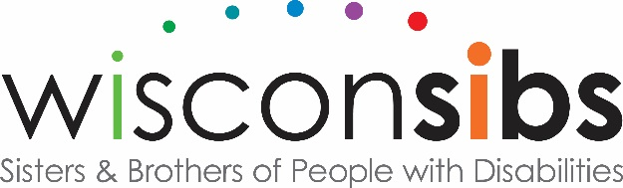
NEWS RELEASE
Contact: Harriet Redman, Executive Director
WisconSibs, Inc.
211 E. Franklin St.
Appleton, WI 54911
920-968-1742 920-450-2609 (call/text) info@wisconsibs.org

Appleton, WI – November 1, 2017
WisconSibs Announces Outstanding Caregivers
Sisters and brothers of children and adults with disabilities or long-term illnesses highly value caregivers, both family and professional. The Sibling’s Choice award, now in its 9th year, gives them the opportunity to recognize outstanding caregivers.
November is National Family Caregivers Month when we celebrate the more than 44 million Americans who care for a family member, friend, or neighbor. In Wisconsin, WisconSibs recently honored two caregivers who were nominated by siblings of people with disabilities with The Sibling’s Choice Award.
LORI MOY, Menasha, received the 2017 Sibling’s Choice Family Caregiver Award. Sue was nominated by her sister Carla Euclide, along with Jon Hartstern who has a disability.
Carla wrote in her nomination: “Lori is involved in every aspect of Jon’s life. She goes above and beyond what is necessary and has drastically changed the quality of his life.
She takes him to all medical and dental appointments, involves John in planning, shopping and preparing meals and housecleaning, teaches him personal hygiene, helped him find employment, sets up social activities and transportation, taught him manners and social skills while building his confidence so that now he’s an usher at church.
She helped him through grieving for their mom, brother, and brother-in-law. She has been his advocate for 40 plus years.”
Also receiving a 2017 Sibling’s Choice Award was AMANDA UPTON, Genoa City, Wisconsin. She was nominated by 8-year-old Charlotte and 6-year-old Eleanor Woelfel, Pulaski, and their little sister Caroline who has disabilities.
The children explained about Upton: “Miss Amanda is very good at taking care of Jilli and Lydia (Caroline’s friends who have disabilities) because she knows a lot of medical stuff. Jilli and Lydia can’t eat by mouth. They have tummy tubes that go into the stomach.

Miss Amanda has to make formula up each night and the girls are fed all day long. Jilli uses oxygen so Miss Amanda fixes it when it beeps and makes sure her numbers look good. She takes the girls to therapy so they can become stronger.
Sometimes one of the girls needs to go to the hospital. Miss Amanda always brings some kind of toy. She does that so the other one is not bored and because Miss Amanda is awesome.
One time, Jilli needed a wheelchair and insurance wouldn’t give it to her but Miss Amanda kept on fighting. It was really hard but she kept on going until Jilli got her wheelchair. We know she cares and that showed us all how even when it’s hard you never stop going.”
The Sibling’s Choice Award nominations are accepted from brothers or sisters of individuals with disabilities. Nominations recognize either family caregivers or professional individuals, including service providers, physicians, attorneys, financial professionals, legislators and advocates who serve and support individuals with disabilities. The awards help siblings acknowledge and honor a caregiver’s contribution to the independence and quality of life of a person with a disability.
This is the 9th year for the award program. Former Governor Martin J. Schreiber, author of My Two Elaines: Learning, Coping, and Surviving as an Alzheimer’s Caregiver, presented the awards at a ceremony held during the Celebrate Sisterhood Luncheon at the Radisson Paper Valley Hotel on October 17, 2017.
WisconSibs, Inc a nonprofit organization dedicated to the interests of people who have siblings with disabilities in the Fox Valley and throughout Wisconsin through peer support programs, education and networking opportunities, social activities, and leadership development.

Below left: Harriet Redman with Amanda Upton, Martin Schreiber and Charlotte and Eleanor Woeflel
Below right: Jon Herstern and his sister Lori Moy with family and Martin Schreiber.
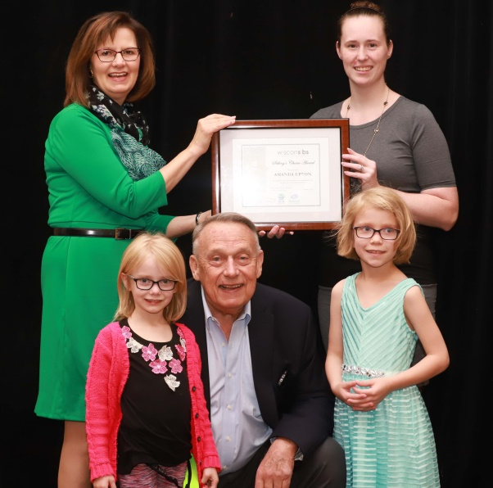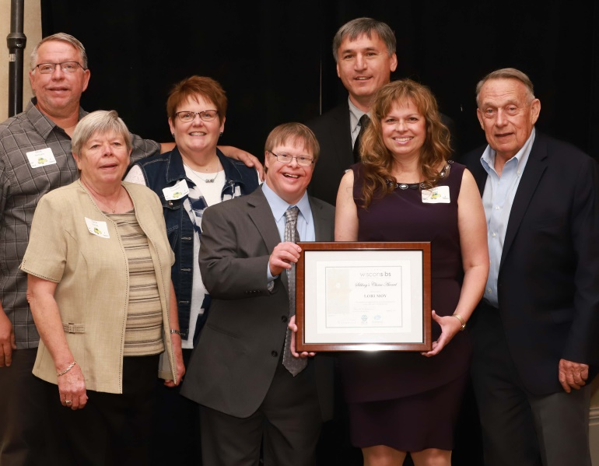
More information/photos available. Contact Harriet Redman
--end—

