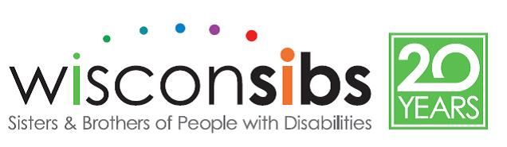
WisconSibs Scholarship/Campership Application

WisconSibs seeks out donors and conducts fundraisers to make it possible for siblings to attend programs if financial strain would otherwise make it impossible. Requests are considered on a first-come, first-served basis and requests are not guaranteed. If you need financial support to attend a WisconSibs program, please complete the following application and mail it to WisconSibs, 211 E. Franklin, Appleton, WI 54911.

You will be notified about the status of your request by email (from info@wisconsibs.org) within 10 days*.

Parent Name ______________________________________ Phone(s) ________________ _______________
Full Name of child enrolling in camp ___________________________________________________________

Address ___________________________________________ City __________________ St ___ Zip _______

Email ___________________________________________

Is there another child in the family enrolling in a WisconSibs program? __yes Name _______________________

Check which of the following your family currently utilizes (check all that apply):
__ WIC __ Head Start __ Free or reduced lunch
__ Birth to 3 __ IEP __ SSDI
__ Foster care __ Unemployment Insurance __ Other public assistance _________________

Please indicate the event you wish to attend:

___ Sibshops (approximately monthly) fee $15/Sibshop

___ SibDays of Summer 2019 (Plamann Park) fee $35/day or $150/week
July 22-26, 2019

___ Sib Camp 2019 (Door County)

__ Ages 9-16 TENTS (June 20-23) fee $275
__ Ages 9-11 YURTS (August 8-11) fee $325
__ Ages 12-16 YURTS (August 15-18) fee $325

Please indicate the amount you can pay toward the fee of the event and enclose with your registration form for that event. The amount you are unable to pay will be provided by our generous donors*.

__ $300 __$250 __ $200 __ $150 __$100 __$75 __$50 __ $25 __ $10 __ $0

Camperships are not paid to recipients, nor do they apply to any other event than the one indicated on this form.

Thank you for your interest. If you have any questions, please contact:

WisconSibs, Inc
920-968-1742
info@wisconsibs.org Office use only
__ Award immediately __ full amount __ part amount __________
__ Pending available funds
__ More information needed
__ Ineligible or no longer needed
Updated Jan 2019

