Community of Practice on Autism Spectrum Disorder and other Developmental Disabilities (CoP ASD/DD)
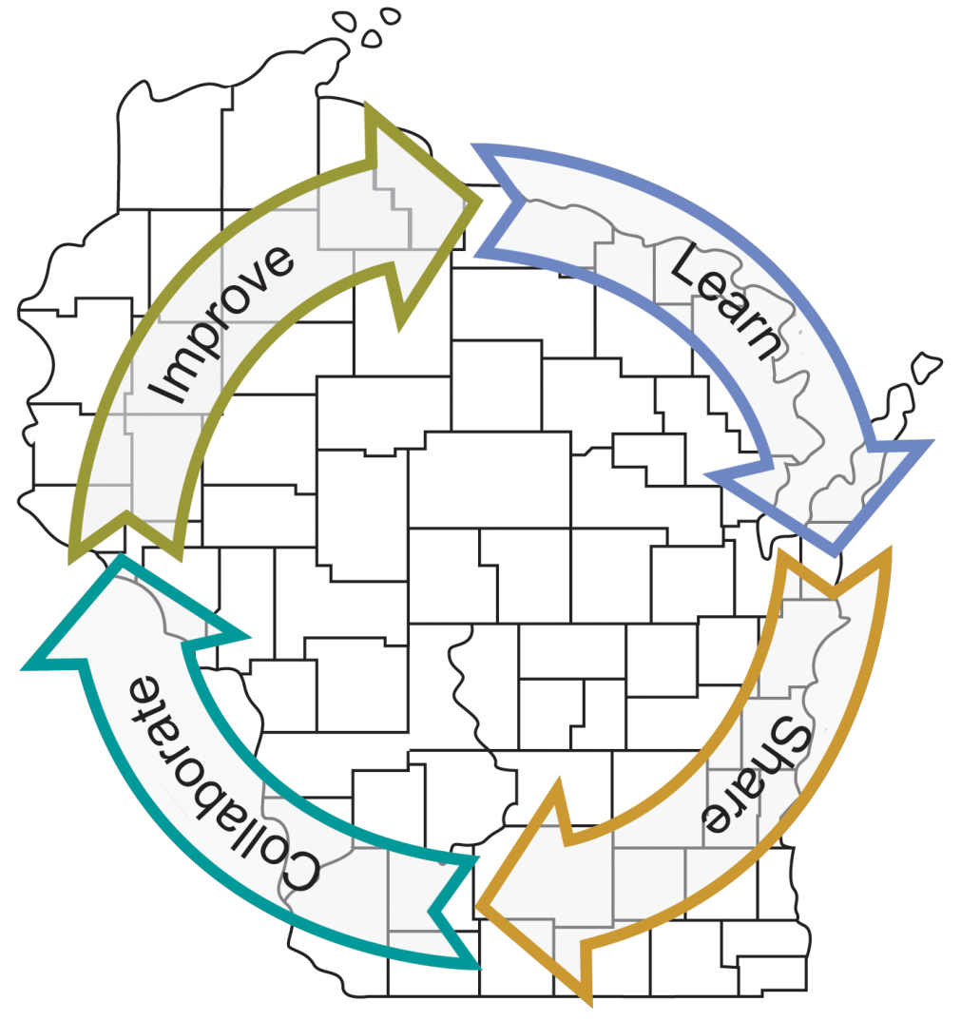
Access to Mental Health Services for People with Autism Spectrum Disorder and other Developmental Disabilities
A Multi-site Distance Event
Learn together; Collaborate locally
Presentation Topics:
- Barriers to accessing services in Wisconsin
- Medicaid benefits
- Talking with mental health professionals (tentative)
- Supporting families
Tuesday, February 12, 2019

8:30am to 12:30pm

Sign-in begins at 8:15am
[This is a free event but you must register]

Hosted at the Waisman Center at UW Madison with multiple viewing/discussion sites around Wisconsin!
Please join us IN APPLETON at:
211 E Franklin St., Appleton, WI
For information about the CoP ASD/DD and to check for updates www2.waisman.wisc.edu/cedd//connections/future_meetings.php

REGISTER online at https://go.wisc.edu/copfeb2019-- Choose your site during registration!

If you have any trouble with this registration or do not have access to a computer to register—please contact Sonja Oetzel at (608) 265-8955 or email her at soetzel@wisc.edu.
Thank you to our partners and our sites:
UW-Madison Waisman Center LEND Program
Advocates for Health Transitional Living Nicolet College Chequamegon School District
ADRC of Brown County Oneida Behavioral Health UW-Milwaukee
Autism Society of Wisconsin Oshkosh Area School District
Barron Area Schools& Community Center Shepherd’s College
CESAs 8, 9 and 12 SOAR Fox Valley
Chileda UW-Platteville
Greendale School District UW-Superior Center for Continuing Education
The Human Service Center Westby School District
Kenosha Unified Schools WisconSibs
KGH Autism Services Wisconsin CYSHCN Regional Centers
Marathon County Health Department Wisconsin Early Autism Project (WEAP)
Midstate Independent Living Choices Wisconsin Indianhead Technical College
Department of Health Services Title V Children and Youth with Special Health Care Needs Program
UW-Madison Waisman Center University Center for Excellence in Developmental Disabilities

